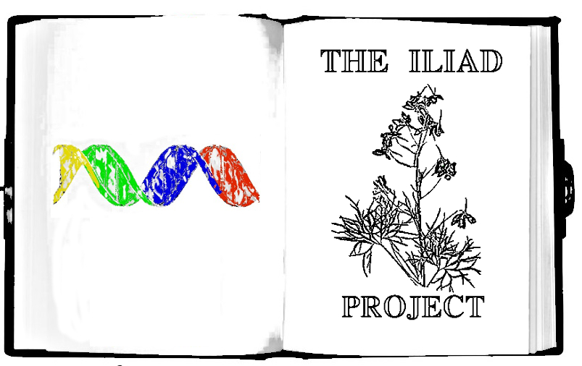

The search for natural antibiotics in what we see everyday.

This guide can be found at: http://goo.gl/sj4Wvy

This kit allows you to test many different types of samples for their ability to kill bacteria or stop bacterial growth.

Part 1. Testing Plants and Other Organisms that Need to be Ground Up

Part 2. Testing Bacteria and Fungus

Contents of the Kit

20 - Plates

1 - Mortar and Pestle

5 - Syringes

Cell Spreaders

200 - Filter Paper Test Discs

1mL - Antibacterial Control(Labelled Kan or Kanamycin or Antibiotic)

5 - 15mL Culture Tubes with LB Media

2 - 15ml Tubes with LB AGAR

5 - Empty 15mL Culture Tubes

5 - Pairs of Nitrile Protective Gloves

50mL - Buffer

5 - Syringe Filters

5 - Blunt end Yellow syringe tips

25 - Microcentrifuge Tubes to Store Samples

*Escherichia coli* Bacteria BL21

Inoculating Loop

Plate spreader

Each plate can test ~2 Samples for a total of about 40 samples that can be tested.

A few things to keep in mind when performing experiments

* The bacteria you are testing cannot harm you but it is very very similar to bacteria that can harm. This makes it a perfect safe substitute to test for antibiotics and learn Science.
* Attempt to Document your experiments as thoroughly as possible by taking pictures or videos and writing about it. This allows you and other people to replicate the experiment if something interesting is found.
* If you find leaves or samples on the ground rinse them in water before you test them as they can accumulate chemicals from cars and pollution and many other things.
* **There are many things that can kill bacteria that are not very useful as antibacterial for human consumption such as things with high salinity(lots of salt), things with low pH(very acidic), oils, detergents and soaps. Try and avoid these things.**
* For testing Bacterial and Fungal samples it is recommended that you purchase isopropyl alcohol from your local grocery store for sterilizing gloves and utensils.
* You can document your experiments by going to <http://www.the-iliad.org> which will redirect you to our Synbiota page

**Part 1. Testing Plants**

**Day 1: Prepping Bacteria, collecting samples and making agar plates**

1. Start a culture of bacteria in a 15mL tube. Add water to the 10mL line and shake till media is dissolved, then take a piece of filter paper that contains the *E. coli* bacteria and stick it in the liquid. In a pinch you can always use a swab of your skin to grow up bacteria!
2. You need to let the bacteria grow so there is enough for a few tests. Let the tube sit in a warm place with cap slightly unscrewed, to allow oxygen in, for 24-48 hours or until solution starts to become cloudy. The bacteria is non-pathogenic, meaning it cannot cause any disease and is similar to bacteria on your body. And can be cleaned up with soap and washed down the drain.

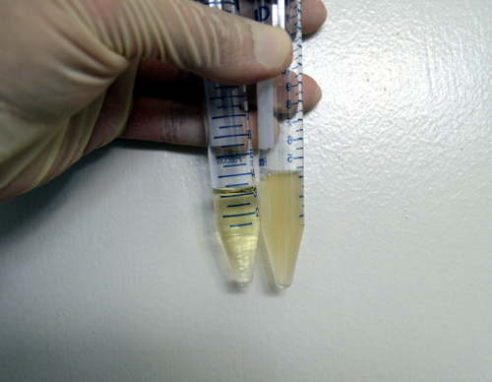

The Yellowish but clear liquid is media with no bacterial growth(Left). The Yellowish and cloudy liquid indicates bacterial growth(Right).

1. While waiting for your bacteria to grow Collect your Sample. When you collect your sample make sure that you collect enough to store for further analysis if the antibacterial assay is a success. Record GPS coordinates and take pictures of the plant or specimens collected for identification and posting on the website(<http://www.the-iliad.org>)
2. (See more detailed directions [[how to make plates]](https://docs.google.com/document/d/1UcbshGXeTEyNg-4ZxiJDeOM8r6mN5CZDreM5c7n6bzE/edit). To make your plates add one packet or tube of the LB agar powder to150mL water(measure with 50mL tube provided) and microwave until dissolved. Let the agar cool down to 50C or until you are able to touch the bottle without too much discomfort. Pour enough LB agar to fill bottom of plate(the bottom is the smaller side of the plate)(each packet should make ~10 plates) and then let cool and solidify. Store plates at 4C in the fridge for later use. Plates will last a few weeks to a few months.

**Day 2: Process your Samples**

1. **Once your bacteria is grown from Step 2 you should proceed to Step 6**
2. Place your sample in the mortar, add buffer(~1mL) using the syringe and yellow syringe tip and grind. The amount of buffer you add should depend on the amount of sample you have. **The less sample the less buffer because you want to keep the plant extract concentrated.**
3. Take 0.5mL of bacteria from culture you started in a previous day and spread over the entire plate using the plate spreader. If you are having difficulty seeing bacteria at the end of the assay add more next time.
4. Let the bacteria dry on the plate before you continue(10 minutes).
5. Mark the back of the plate in 8 different sections like a pizza and label sections with which sample you will put in it. Label one section for your antibacterial control and one section for your buffer control. Do three sections per specimen to allow for reproducibility.

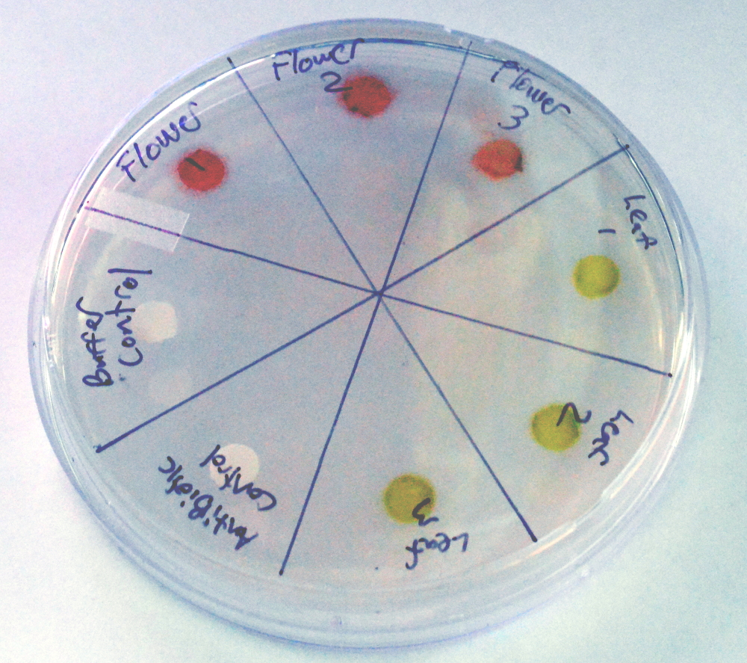

1. Using tweezers take a paper disc and allow it to soak up a drop of each sample. For your control sections put a drop from your buffer tube and antibiotic control tube(Kan) on paper discs and put them in their sections on the plate. Make sure you rinse tweezers after using the antibiotic or it could transfer to other disks and confuse your results.
2. **Controls are a very important part of Science experiments.** They give us a baseline to compare to to make sure that any variables we have not accounted for are giving us the results we see. The Antibiotic control is considered a positive control and it used to compare the plant extracts to so you can determine how well or not well the extract is working. The buffer control is a negative control, meaning you should see no effect. if there is an effect it could mean your buffer is contaminated, retest it and if there is still a problem switch to distilled water.
3. Take a picture of your plate and then take a picture after 12 hours and 18 hours(times do not need to be exact).
4. Bacterial growth will be visible on the plate and make the plate look cloudy. A clear ring should form around your antibiotic control and your buffer control should have no effect. If your sample has antibacterial properties you should also see a clear ring around the paper disc like you see in the antibiotic control in the picture below. Whether the effect is positive or negative it can contribute to Science so please document your experiment online by using one of the experiments already posted as a template.

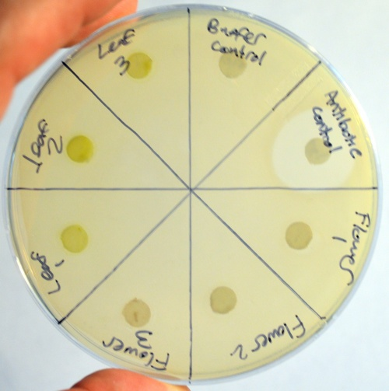

**Part 2. Testing Bacteria, Yeast, Fungus and Other Micro-organisms**

1. Collect your Sample. Bacteria and Fungus can be found most any place but often the most common place people look is in soil. Collect a soil sample or use a sterile swab to swab somewhere.

* When you collect your sample make sure that you collect enough to store for further analysis if the antibacterial assay is a success(collect two samples worth store the back-up sample in an 1.5mL tube). Record GPS coordinates(Cell phone apps are the easiest way to do this I use <https://play.google.com/store/apps/details?id=com.mygpscoordinates>) and take pictures of the specimens collected for identification and posting on the website.

1. Put your soil sample in a clean 15mL tube and add ~3mL of buffer to your sample or enough so there is a layer of liquid and shake. Allow the soil and particulates to settle. Using a syringe or sterile swab remove a few drops of the liquid and put it on an agar plate and let sit for a few days. Overnight, you should see some bacterial growth but some bacteria and fungi take longer to grow so keep the plate for a few days. Make sure you take pictures of the plate and which bacteria or fungus you choose.

**Bacteria Fungus**

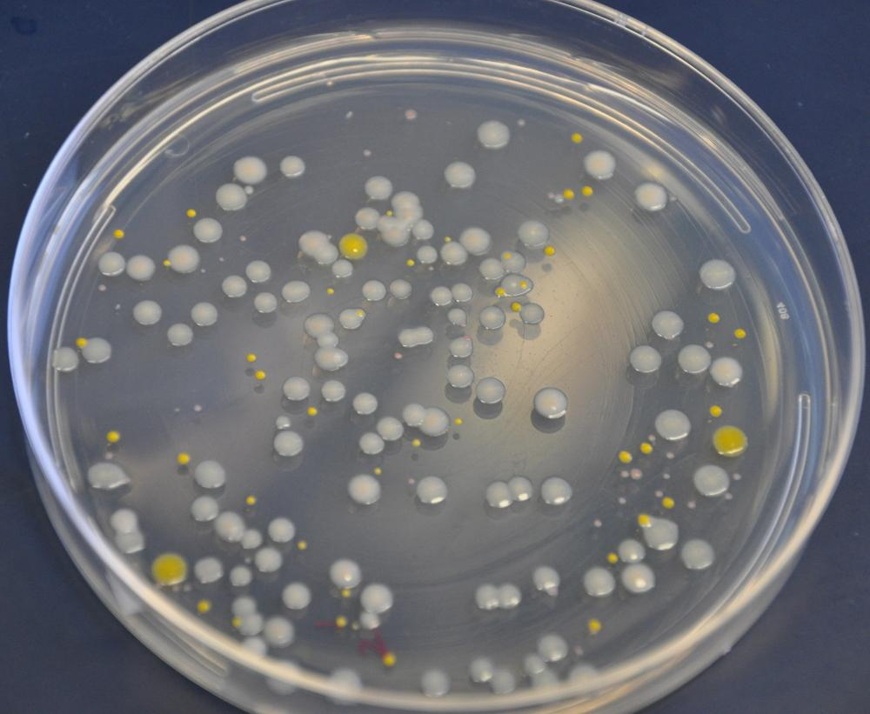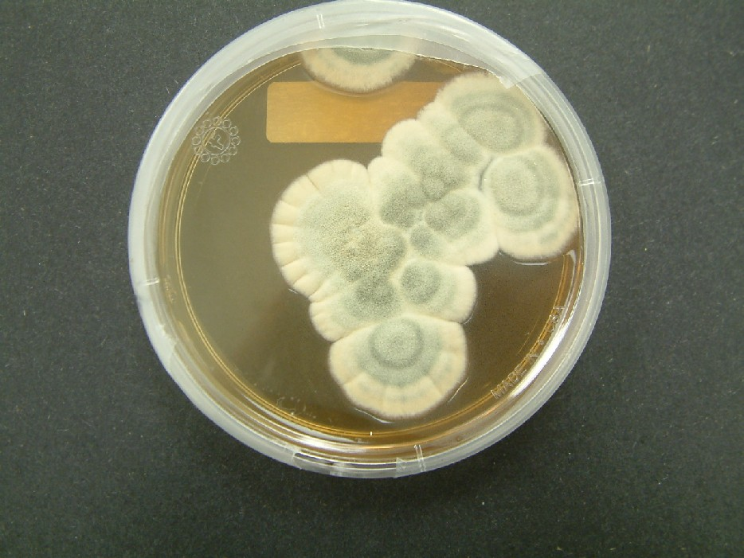

The way to tell the difference between bacteria and fungus is that bacteria usually are single color circular dots, while fungus are “furry”, irregular shaped and can be multiple colors. Yeast will look creamy white and similar to bacteria.

1. **Once you have plate growth from Step 4 you should proceed to step 6**
2. On your plate you should see colonies of bacteria and perhaps fungus. To obtain pure cultures of these organisms, first put on gloves and then clean and sterilize everything! and also the pointy end of your inoculating loop by rubbing isopropyl alcohol on it. Next pick a single colony of bacteria or yeast and stab the pointy end into it and then dip it in a 15mL tube with media. Close the tube and let it sit 24-48 hours or until cloudy. Use a clean workspace and attempt to be as sterile as possible when performing Step 4 to avoid contamination.
3. Start a culture of the testing bacteria by dipping your inoculating loop into the *E. coli* that comes with the kit and then into a 15mL tube with media. You need to let the bacteria grow so there is enough for a few tests. Let the tube sit in a warm place with cap slightly unscrewed, to allow oxygen in, for 24-48 hours or until solution starts to become cloudy. The bacteria is non-pathogenic, meaning it cannot cause any disease and is similar to bacteria on your body and can be cleaned up with soap and washed down the drain.
4. If you have a large amount(at least 1cm diameter) of uncontaminated fungal growth you can use directly by scraping it off the plate using the inoculating loop and put in a 15mL tube and add 1mL of buffer using a syringe then skip to Step 6. If you don’t have significant fungal growth, sterilize and use the loop of your inoculating loop and scrape some sample and spread it around on a new plate. Fungal growth can sometimes be slow and can take 48 hours or more.
5. In order to break open the cells to extract the small molecules that could have antibiotics properties we need to do so without chemicals that can kill the bacteria in our assay. To do this we will do repeated cycles of freezing and heating. Put your tube into the freezer and then thaw by warming in your hands, or by dipping the tube in hot water, or by microwaving for ONLY 5 seconds at a time with the cap screwed tight--don’t heat very long in the microwave or the tube will explode!. Freeze and thaw 2-3 times.
6. Take a ~0.5mL of *E. coli* from culture you started in a previous day and spread over an entire plate using the plate spreader and let dry.
7. Mark the back of the plate in 8 different sections and label sections with which sample you will put in it. Label one section for your antibacterial control and one section for your buffer control. Do three sections per specimen to allow for reproducibility.



1. After the *E. coli* you put on the plate is dry (5-10 minutes) using tweezers take a paper disc and allow it to soak up a drop of each sample. For your control sections put a drop from your buffer tube and antibiotic control tube on paper discs and put them in their sections on the plate.
2. Controls are a very important part of Science experiments. They give us a baseline to compare to to make sure that any variables we have not accounted for are giving us the results we see. The Antibiotic control is considered a positive control and it used to compare the plant extracts to so you can determine how well or not well the extract is working. The buffer control is a negative control, meaning you should see no effect. if there is an effect it could mean your buffer is contaminated, retest it and if there is still a problem switch to distilled water.
3. Take a picture of your plate and then take a picture after 12 hours and 18 hours(times do not need to be exact). This is just for documentation of your experiments.
4. Bacterial growth will be visible on the plate and make the plate look cloudy. A clear ring should form around your antibiotic control and your buffer control should have no effect. If your sample has antibacterial properties you should also see a clear ring around the paper disc.